To create emoji from facial expression using python

Dr. Lutful Islam

Professor, Department of Computer Engineering

M. H. Saboo Siddik College of Engineering

lutful.islam@mhssce.ac.in

Arif Ansari  
Department of Comp. Engg.  
M. H. Saboo Siddik College of Engineering

Mumbai, India  
arifpinto98@gmail.com

Sreejith Nair  
Department of Comp. Engg.  
M. H. Saboo Siddik College of Engineering

Mumbai, India  
1999sreejith098@gmail.com

Azhan Patel  
Department of Comp. Engg.  
M. H. Saboo Siddik College of Engineering

Mumbai, India azhanpatel77@gmail.com

***Abstract---A developing assemblage of exploration investigates emoticons, which are visual images in computer mediated communication (CMC). In a long time since the original set of emoticons was delivered, research on it has been on the expansion, yet in a variety of directions. We inspected the extant group of exploration on emoticons and noticed the turn of events, utilization, capacity, and use of emoticons. The increasing use of emojis, digital images which can represent a word or feeling during a text or email, and thus the undeniable fact that they're going to be strung together to make a sentence with real and full meaning raises the question of whether or not they are creating a replacement language amongst technologically savvy youth, or devaluing existing language. there's however an extra depth to emoji usage as language, suggesting that they're actually returning language to an earlier stage of human communication. Parallels between emojis and hieroglyphics and cuneiform are often seen which indicates the universality of communication forms, instead of written alphabetized language. There additionally are signs that emoticons could likewise be social or gender explicit with signs that women utilize a greater number of emoticons than men to exact their sentiments which age is a smaller amount of an indicator of usage than technological awareness and capability. It appears that emojis are filling the necessity for adding non-verbal cues in data communication about the intent and emotion behind a message. Furthermore, emojis are devices for demonstrating tone, intent and feelings which may normally be conveyed by non-verbal cues in personal communications but which cannot be achieved in digital messages. It's also evident from prior works and analyses of usage that there are universal meanings to Emojis. This means that as a language form, emojis could also be ready to contribute to increased cross-cultural communication clarity. Further research is however recognized as being necessary to completely understand the role that emojis can play as a clear language for all generations, not just those termed millennials or technologically savvy youths. With advancements in computer vision and deep learning, it's now possible to detect human emotions from images. During this deep learning project, we'll classify human facial expressions using Convolution Neural Network to filter and map corresponding emojis or avatars.***

***Keywords - Convolution Neural Network (CNN), Deep learning, Sentiment Analysis, Emojis, new language.***

# I. INTRODUCTION

Nonverbal conduct passes on full of feeling and passionate data, to impart thoughts, oversee connections, and disambiguate significance to improve the effectiveness of discussions [1,2]. One approach to demonstrate nonverbal prompts is by sending emoticon, which are realistic symbols (e.g.😂,🤣,🔥) oversaw by the Unicode Consortium that are distinguished by Unicode characters and delivered by a platform's font bundle.

Emoticons empower individuals to communicate lavishly, and keeping in mind that appeared as screen designs, they can be controlled as text structures. Other than Pohl's Emoji Zoom who propose a zooming-based interface, entering emoticon on cell phone consoles as of now expects clients to make a determination from enormous records (one rundown for every classification of emoticon) (e.g., Apple© iOS 10 emoticon console 2 in Fig. 2.1). This makes emoticon passage "a linear search task" and given the developing number of emoticons, we expect it can bring about client dissatisfaction. While no earlier work expressly addresses this, endeavors, for example, Emojipedia 3 feature the requirement for better emoticon search.

To address this, we propose a framework and strategy to utilize clients' facial emotional expressions as framework input to filter emoticons by emotional classification. In spite of the fact that emoticons can address activities, items, nature, and different symbols, the most normally utilized emoticons are faces which express feelings [4,5,7]. Additionally, past work has shown that emoticons can be positioned by assumption (Emoji Sentiment Ranking by Novak), literary notification containing emoticons display contrasts in 3-esteemed conclusion across stages, and for faces, emoticons can be positioned by valence and arousal.

Momentum research study centers around emotional recognition. The feelings every now and again ease and decide connections among the individuals. The setting of feelings explicitly draws out the mind boggling and strange social correspondence. Social correspondence is distinguished as the judgment of the other individual's temperament dependent on the emoticon. The acknowledgment of feelings can be recognized through different signs by the "body language, voice intonation" just as by means of "more intricate techniques, for example, electroencephalography (EEG)." Nonetheless, the less difficult, and plausible methodology is to analyze facial expression. By noticing the facial expression, the individual's mind-set and conduct are effortlessly judged. Duncan clarified that "there are seven sorts of human feeling [that could undoubtedly be unmistakable with an assortment of meanings] across various societies". This examination includes researching emotional recognition by the constant collections. The feelings are distinguished as happiness, fear, disgust, anger, sadness, surprise and contempt.

This project aims to build a deep learning model to classify facial expressions from the images. Then we will map the classified emotion to an emoji or an avatar.

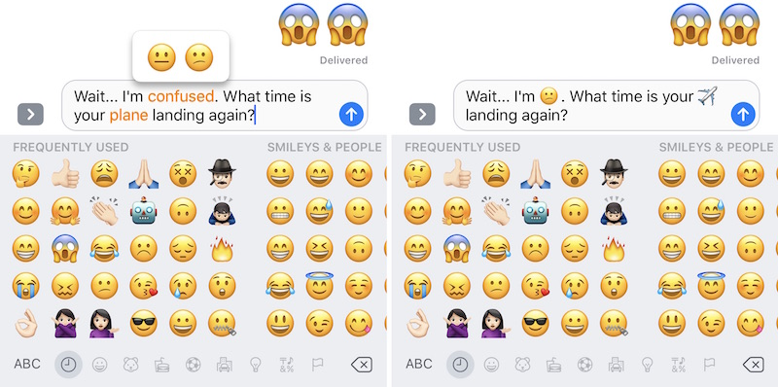

Figure 2.1: Apple© iOS 10 emoji keyboard within iMessage

# II. LITERATURE SURVEY

Today, the most widely recognized method of communication among individuals is virtual platforms, regardless of whether utilizing the web or phones (Vissers and Stolle, 2014). The current age utilizes online applications and stages to impart and trade discussions. Be that as it may, imparting emotions is troublesome. Thus, little and straightforward pictures, also called emoticon characters, are utilized to enhance feelings when utilizing composed language (Yeole, Chavan, and Nikose, 2015). They have extraordinary semantic and passionate highlights, but on the other hand are firmly identified with marketing, law, medical care and numerous different zones. The examination on emoticons has become an interesting issue in the scholastic field, and then some and more researchers from the fields of computing, communication, marketing, behavioral science, etc. are considering them. Emoticon characters are turning out to be increasingly more promoted hence the variety of these characters has expanded. Be that as it may, the current existing emoticon characters are restricted to predetermined characters. Also, these characters need intricacy and variety. To customize emoticon characters, this examination investigated techniques for clients to "emojify" their photos. This study not just permits individuals to make altered and exceptional methods of imparting emotions, yet in addition makes justification for additional upgrades of emoticon characters.

It is roused by two discoveries from the literature: that an essential capacity of emoticons is to communicate emotions, and that most emoticons utilized are face emoticons. Cramer tracked down that 60% of their dissected messages by US members were emoticons utilized for communicating emotions. In an Instagram emoticon study, faces represented 6 of the main 10 emoticons utilized, giving additional proof that individuals as often as possible use emoticons to communicate emotions. Moreover, as indicated by a 2015 SwiftKey report, faces represented near 60% of emoticon use in their examination of billions of messages. At last, in a subjective report from Lee on emoji sticker utilization, they tracked down that these stickers were utilized fundamentally for communicating emotions.

1. Survey of Existing System

*Multimodal User Interfaces and Emoji Entry*

Identified with our methodology, Filho et al. augmented text chatting in mobile phones by adding automatically identified facial expression responses utilizing computer vision methods, bringing about an emotion upgraded mobile talk. For utilizing the client's face as information, Anand et al. investigated a utilization instance of an eBook reader application wherein the client plays out certain facial expressions normally to control the gadget. Concerning emoticon section, Pohl et al. proposed another zooming keyboard for emoticon passage, EmojiZoom, where clients can see all emoticons immediately. Their strategy, which was tried in a convenience concentrate against the Google keyboard, showed 18% quicker emoticon entry.

*Emoji and Emoticon Communication*

The smallness of emoticons diminishes the exertion of contribution to communicate feelings, yet in addition serves to change message tone, increment message commitment, oversee discussions and keep up friendly connections. Additionally, emoticons don't have language obstructions, making it feasible for clients across nations and social foundations to impart. In an examination by Barbieri et al., they tracked down that the general semantics of the subset of the emoticons they considered is protected across US English, UK English, Spanish, and Italian. As approval of the convenience of planning emoticons to feelings, primer examinations announced by Jaeger et al. recommend that emoticons may have potential as a strategy for direct estimation of emotional relationship to food varieties and drinks.

1. Limitations of Existing system

*Emoji Mis-interpretation*

As of late, Miller et al. exhibited how a similar emoticon looks diversely across gadgets (iPhone, Android, Samsung) and is in this way contrastingly deciphered across clients. In any event, when members were presented to a similar emoticon delivering, they differed on whether the assumption was positive, unbiased, or negative around 25% of the time. In a connected primer investigation, Tigwell et al. discovered clear contrasts in emoticon valence and arousal evaluations between stage matches because of contrasts in their design, just as varieties in appraisals for emoticons inside a stage. With regards to our work, this features the need to represent different translations, where an emoticon can be delegated having a place with at least one emotion class.

# III. PROPOSED SYSTEM

1. Details of Hardware & Software

*Hardware Requirements*:

Smart phone (3G & more), Camera (8MP & above)

*Software Requirements*:

* Operating System: Windows 7/8/8.1/10, Linux
* Database: Firebase/MySQL/MongoDB
* Tools and Framework: OpenCV, Tensorflow, Android Studio
* Language Requirement: Python, Kotlin/Java
* Server: Locally hosted

*Technology Used*:

Image pre-processing, TensorFlow, Keras, OpenCV and Google Collab, Deep Learning, Image Processing, Android/Mobile Application Development

1. System

This project will consist of creating two important inter-dependent modules. They can be described as follows:

* Android Application (UI)
* Server (Database and Deep Learning model)

Server: (Deep Learning Phase)

* Preprocess the input image from the train dataset collected from sources such as Kaggle as well as creation of the dataset using one's own facial expression.
* Process it in R-CNN/CNN for Facial Expression Detection and Emotion Classification.
* Update Facial Data in Database for corresponding session with output results from DL model
* Send corresponding update to Android Application

Server (Database):

* Store User related details such as Name,Google Account ID.
* Store results of submission with classified emoji,Emotion and Expression.
* Database will be implemented using MongoDB/Firebase.

Android:

* Provide User-Interface to the user.
* Generate and maintain a profile of users for future use in integration.
* Create emoji based on expression.

1. Analysis/Framework/Algorithm

*Tensorflow*

TensorFlow is a free and open-source software library for machine learning. It can be used across a range of tasks but has a particular focus on training and inference of deep neural networks. Tensorflow is a symbolic math library based on dataflow and differentiable programming. It is the fastest and simplest way to do image recognition on your laptop or computer without any GPU because it is just an API and your CPU is good enough for this. TensorFlow provides the opportunity to adapt a pre-trained model to new classes of data with several advantages.

*Create Training Data*

In Preparation for training data we are going to capture video through webcam using a python program consisting of opencv and imutils also implement the HAAR cascade classifier and create an image dataset by capturing the frames of specified emotion as a facial expression.

Another alternative is to download images from Kaggle which have already defined a dataset for emotions, such as the FER2013 dataset.

*AndroidStudio*

Android Studio is the official Integrated Development Environment (IDE) for Android app development, based on IntelliJ IDEA. On top of IntelliJ's powerful code editor and developer tools, Android Studio offers even more features that enhance your productivity when building Android apps, such as a flexible Gradle-based build system, a fast and feature-rich emulator, a unified environment where you can develop for all Android devices, apply Changes to push code and resource changes to your running app without restarting your app, code templates and GitHub integration to help you build common app features and import sample code.

Require a camera user interface that is customized to the look of their application or provides special features. Guide is for the older, deprecated Camera API. For new or advanced camera applications, the newer android.hardware.camera2 API is recommended.

The general steps for creating a custom camera interface for your application are as follows:

*Detect and Access Camera* - Create code to check for the existence of cameras and request access.

*Create a Preview Class* - Create a camera preview class that extends SurfaceView and implements the SurfaceHolder interface. This class previews the live images from the camera.

*Build a Preview Layout* - Once you have the camera preview class, create a view layout that incorporates the preview and the user interface controls you want.

*Setup Listeners for Capture* - Connect listeners for your interface controls to start image or video capture in response to user actions, such as pressing a button.

*Capture and Save Files* - Setup the code for capturing pictures or videos and saving into database (Firebase) and process for the output.

*Release the Camera* - After using the camera, your application must properly release it for use by other applications.

*OpenCV*

OpenCV (Open Source Computer Vision Library) is an open source computer vision and machine learning software library. OpenCV was built to provide a common infrastructure for computer vision applications and to accelerate the use of machine perception in commercial products. Being a BSD-licensed product, OpenCV makes it easy for businesses to utilize and modify the code. It supports C++, Python, Java, Android SDK, etc. The library has more than 2500 optimized algorithms, which includes a comprehensive set of both classic and state-of-the-art computer vision and machine learning algorithms. These algorithms can be used to detect and recognize faces, identify objects, classify human actions in videos, track camera movements, track moving objects, extract 3D models of objects, produce 3D point clouds from stereo cameras, stitch images together to produce a high resolution image of an entire scene, find similar images from an image database, remove red eyes from images taken using flash, follow eye movements, recognize scenery and establish markers to overlay it with augmented reality, etc. It has C++, Python, Java and MATLAB interfaces and supports Windows, Linux, Android and Mac OS. OpenCV leans mostly towards real-time vision applications and takes advantage of MMX and SSE instructions when available. A full-featured CUDA and OpenCL interface is being actively developed right now. There are over 500 algorithms and about 10 times as many functions that compose or support those algorithms. OpenCV is written natively in C++ and has a templated interface that works seamlessly with STL containers.

1. Design Details

Flowchart

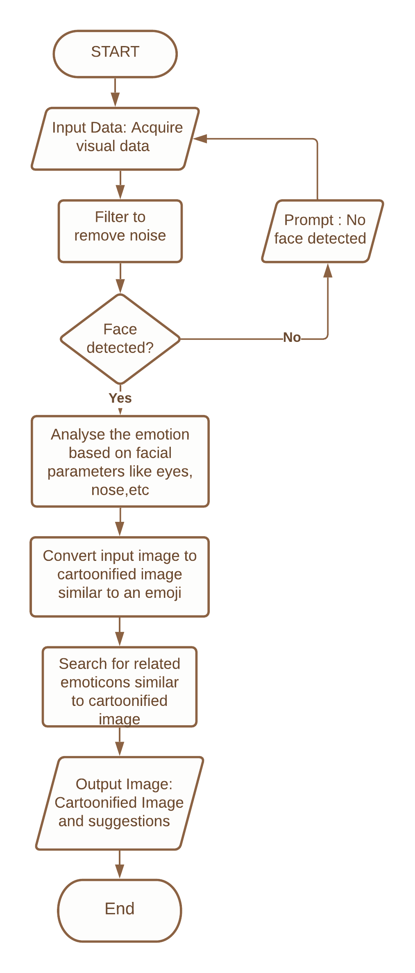

Data Flow Diagram

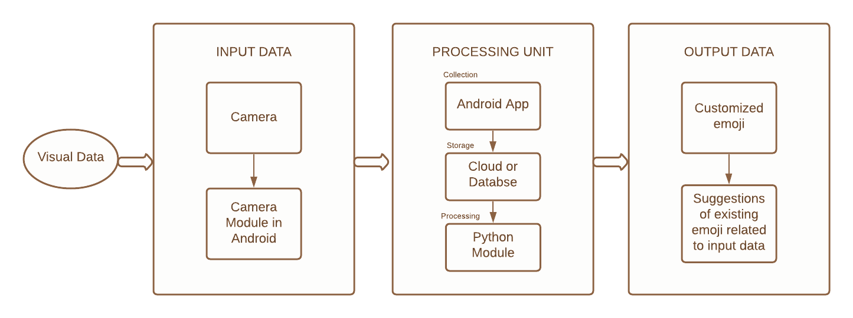

Use Case Diagram

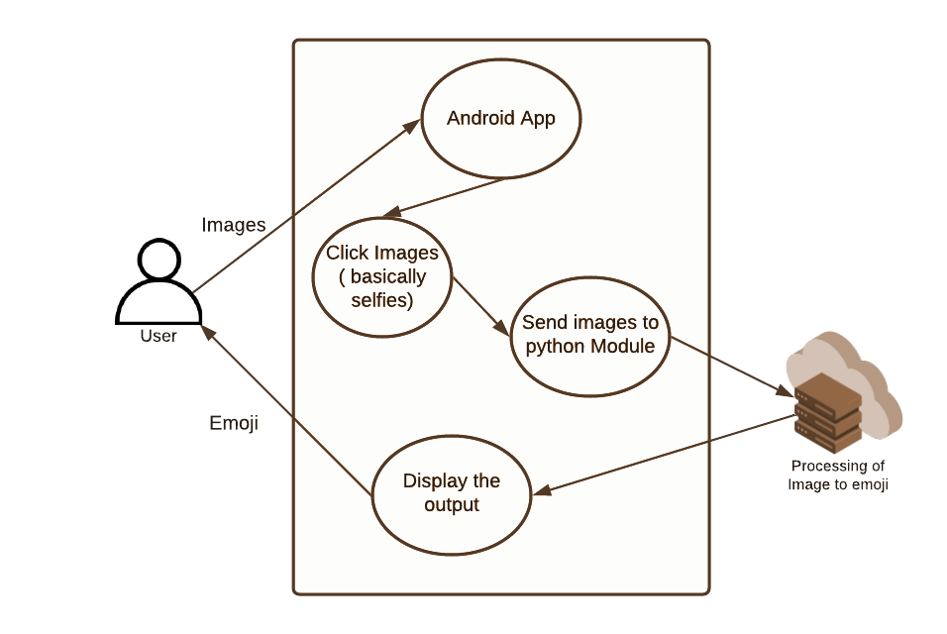

1. Steps followed by the proposed system

Step 1: Input the dataset

Below are sample images from the FER 2013 dataset that are used to classify emotions. These Images are categorized based on the emotion shown in the facial expressions such as happiness, neutral, sadness, anger, surprise, disgust, fear.

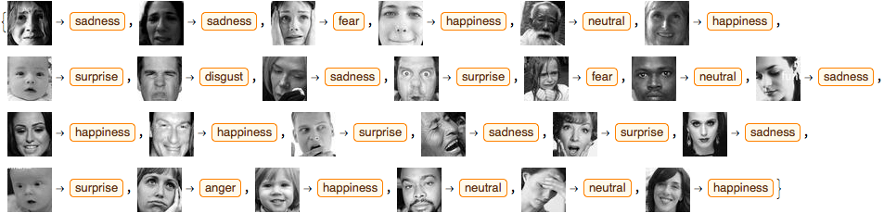

Step 2: Data pre-processing and applying augmentation Strategies.

Image data augmentation is used to expand the training dataset in order to improve the performance and ability of the model to generalize. Images are rescaled from [0,255] to [0,1] using the ImageDataGenerator python module. Benefits of this are:

* *Treat all images in the same manner*: some images are high pixel range, some are low pixel range. The images are all sharing the same model, weights and learning rate. The high range image tends to create stronger loss while low range creates weak loss, the sum of them will all contribute to the back propagation update.
* *Using typical learning rate*: when we reference the learning rate from other's work, we can directly reference their learning rate if both works do the scaling preprocessing over images data set. Otherwise, higher pixel range image results in higher loss and should use a smaller learning rate, lower pixel range image will need a larger learning rate.

Step 3: Neural Network architecture.

After pre-processing the dataset, the next step is to build a convolutional neural network. The convolution layer consists of the input layers, the hidden layers and the output layer. Depending on the architecture that is built in the neural network we add convolutional layers with filters. Below is the architecture of the neural network.

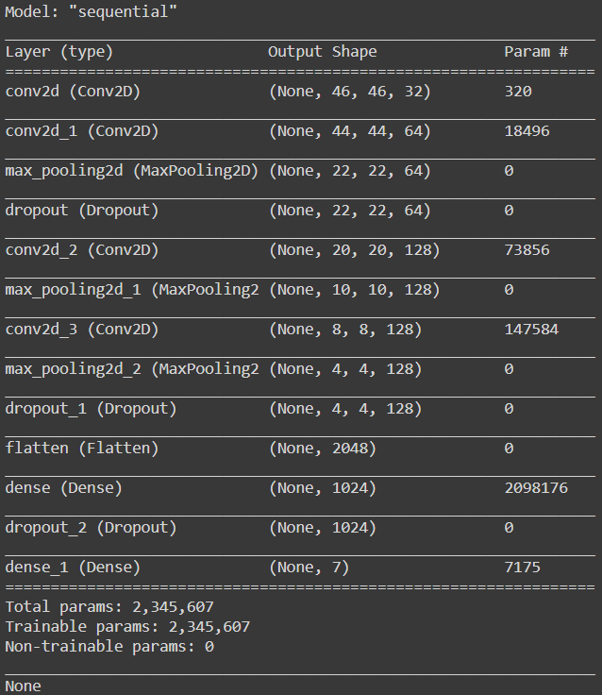

Step 4: Accuracy and loss.

With the implementation of the above neural network, we got accuracy of 0.8726 and loss of 0.3622.

# IV. Conclusion

Emojis are ways to indicate nonverbal cues. These cues have become an essential part of online chatting, product review, brand emotion, and many more. It also led to increasing data science research dedicated to emoji-driven storytelling. We build a convolution neural network architecture and train the model on FER2013 dataset for emotion recognition from images also with advancements in computer –vision and deep learning, it is now possible to detect human emotions from images. In this project, we will classify human facial expressions to filter and map corresponding emojis.

# V. References

[1] Mark L. Knapp and Judith A. Hall. 2010. Nonver-bal Communication in Human Interaction (7 ed.).Wadsworth: Cengage Learning, Bosten, USA

[2] Jessica L Tracy, Daniel Randles, and Conor M Steck-ler. 2015. The nonverbal communication of emotions.Current Opinion in Behavioral Sciences 3 (2015), 25– 30. DOI:http://dx.doi.org/10.1016/j.cobeha.2015.01.001 Social behavior.

[3] Henning Pohl, Dennis Stanke, and Michael Rohs.2016. EmojiZoom: Emoji Entry via Large OverviewMaps &#128516;&#128269;. In Proc. MobileHCI’16. ACM, New York, NY, USA, 510–517. DOI:http://dx.doi.org/10.1145/2935334.2935382

[4] Henriette Cramer, Paloma de Juan, and Joel Tetreault.2016. Sender-intended Functions of Emojis in USMessaging. In Proc. MobileHCI ’16. ACM, New York,NY, USA, 504–509. DOI:http://dx.doi.org/10.1145/2935334.2935370

[5] Joon Young Lee, Nahi Hong, Soomin Kim, JonghwanOh, and Joonhwan Lee. 2016. Smiley Face: Why WeUse Emoticon Stickers in Mobile Messaging. In Proc.MobileHCI ’16. ACM, New York, NY, USA, 760–766.DOI:http://dx.doi.org/10.1145/2957265.2961858

[6] Petra Kralj Novak, Jasmina Smailovi´c, Borut Sluban,and Igor Mozetiˇc. 2015. Sentiment of Emojis. PLOSONE 10, 12 (12 2015), 1–22. DOI:http://dx.doi.org/10.1371/journal.pone.0144296

[7] Garreth W. Tigwell and David R. Flatla. 2016. OhThat’s What You Meant!: Reducing Emoji Misunder-standing. In Proc. MobileHCI ’16. ACM, New York, NY,USA, 859–866. DOI:http://dx.doi.org/10.1145/2957265.2961844

[8] Channary Tauch and Eiman Kanjo. 2016. The Role Of Emojis in Mobile Phone Notiﬁcations. In Proceed-ings of the 2016 ACM International Joint Conferenceon Pervasive and Ubiquitous Computing: Adjunct (Ubi-Comp ’16). ACM, New York, NY, USA, 1560–1565. DOI:http://dx.doi.org/10.1145/2968219.2968549

[9] Jackson Feijó Filho, Thiago Valle, and Wilson Prata. 2014. Non-verbal Communications in Mobile Text Chat: Emotion-enhanced Mobile Chat. In Proc. MobileHCI ’14. ACM, New York, NY, USA, 443–446. DOI: http://dx.doi.org/10.1145/2628363.2633576

[10] B. Anand, B. B. Navathe, S. Velusamy, H. Kannan, A. Sharma, and V. Gopalakrishnan. 2012. Beyond touch: Natural interactions using facial expressions. In proc. CCNC ’ 12. 255–259. DOI: http://dx.doi.org/10.1109/CCNC.2012.6181097

[11] Francesco Barbieri, German Kruszewski, Francesco Ronzano, and Horacio Saggion. 2016. How Cosmopolitan Are Emojis?: Exploring Emojis Usage and Meaning over Different Languages with Distributional Semantics. In Proc. MM ’16. ACM, New York, NY, USA, 531–535. DOI:http://dx.doi.org/10.1145/2964284.2967278

[12] Sara R. Jaeger, Leticia Vidal, Karrie Kam, and GastÃ3n Ares. 2017. Can emoji be used as a direct method to measure emotional associations to food names? Preliminary investigations with consumers in {USA} and China. Food Quality and Preference 56, Part A (2017), 38 – 48. DOI:http://dx.doi.org/10.1016/j.foodqual.2016.09.005

Hannah Miller, Jacob Thebault-Spieker, Shuo Chang, Isaac Johnson, Loren Terveen, and Brent Hecht. 2016. "blissfully happy" or "ready to fight": Varying interpretations of emoji. In Proc. ICWSM 2016. AAAI press, 259–268